**CHAPTER ONE**

**INTRODUCTION**

**1.1 INTRODUCTION**

Today’s modernization flow of the world has witnessed tremendous change in lifestyle of society. Computerized system in managing laundry has been well accepted especially in developing countries. This service is well accepted because it gives flexibility in terms of time for laundry management team to use it and this really helps them with their time management.

A significant part of the operation of any laundry firm involves the acquisition, management and timely retrieval of great volumes of information. This information typically involves; customer personal information and clothing records history, user information, price of delivery and retrieval period, users scheduling as regards customers details and dealings in service rendered, also our products package waiting list. All of this information must be managed in an efficient and cost wise fashion so that the organization resources may be effectively utilized.

The goal of laundry management system is to automate the management of the laundry firm making it more efficient and error free. It aims at standardizing data, consolidating data ensuring data integrity and reducing inconsistencies, through the use of highly computerized process that is stress free, reliable and quick through the use of asp.net computer programming language and SQL database application to both the users and the staff in charge of the registration and laundry management processes. HTML would be at the front-end and provide the graphical user interface that relates with the user, while the SQL database will be at the back-end to handle the data storage process.

This chapter shall cover background of the study, statement of problem, aim and objectives of the study, significance of the study as well as the scope of the study among other things.

**1.2 BACKGROUND OF THE STUDY**

Aden Fabric Laundry and Dry-cleaning Service currently uses a manual system for the management and maintenance of critical information. The current system requires numerous paper forms, with data stores spread throughout the Laundry firm management infrastructure. Often information (on forms) is incomplete, or does not follow management standards. Forms are often lost in transit between departments requiring a comprehensive auditing process to ensure that no vital information is lost. This has led to inconsistencies in various data due to large volume of contrasting customer details leading to mix-up of clothes in the laundry firm which leads to delay in collecting the clothes back. With this system, it will ensure the availability of needed services to consumers. Due to the many cleaning services system as manual that affects waste or inefficiency of time, data inaccuracies, errors repeated so the writer tries to computerized valet service process in the hope of providing data or information fast, precise, accurate and efficient.

**1.3 STATEMENT OF THE PROBLEM**

The use of existing system also creates an additional workload for staff to keep and obtain the financial, customer and staff information because this information is kept in a different file.

1. Inaccurate Financial Record: Most Laundry firm cannot give proper account of financial flow in the company because no proper account keeping, most times some transaction is not recorded due to hurray the strength to right it in the company book.
2. Time Consumption: Manual systems are time consuming, as the business owner must keep track of Laundry sales on a daily basis, while updating the system manually at the end of the day.
3. Poor Communication: A manual Laundry system requires employees and managers to write down each time a service been processed in the Laundry. If one employee forgets to mention that the last cloths has been brought to the Laundry, a manager expects there is not cloths brought to the Laundry. Compared with a technical Laundry system, a manual Laundry system does not help the communication in the workplace.
4. Physical Counts: A manual Laundry system does not provide any number, as all numbers from the Laundry are gained through physical Laundry counts. One of the difficulties of two running a manual Laundry system is that physical Laundry counts must be performed frequently to control the services in the Laundry. This is time consuming and can cost the business money, if employees must come in to help out outside of business hours.

**1.4 AIMS AND OBJECTIVES OF THE STUDY**

The aim of this project is to design and implement an automated laundry accounting management system that will achieve the following goals, they include:

1. Accurate Financial Flow: the proposed system will store all transaction and also provide financial report for the management during decision making.
2. Computerized System: The proposed system will implement the computerized system which can perform a better managing process of financial information for the laundry. The data of the laundry service and the customer will be kept in the save manner without the problem of losing the data.
3. System and User Privileges: System and user privileges will be implemented in the proposed system to setting up the user level for each system user. This function is to provide the limitation of system accessing.
4. Increase time performance: The time management is very important for the laundry management to ensure the service performs in better condition and on time and it make the business process will be more effective and faster.

**1.5 SIGNIFICANCE OF THE STUDY**

The new system is design to solve problem affecting the manual system in use. It is design to computerized accounting and general information of the laundry thereby relieving the management in accounting record and both customer and services from much stress as experienced from the manual system. This will do the analyzing and storing of information either automatically or interactively, it will make use of computerized system to access the information. The proposed system will also have some features like.

1. This system provides auto calculation of the payment.
2. There is one important function provided where the information about the finance can be analysis.
3. Its Provide functions of editing services details.

**1.6 SCOPE OF THE STUDY**

The scope of the study will cover a complete management system of information in laundry industries where all information will be stored and maintained

**1.7 LIMITATION**

During development of this project work, different challenges were encountered. These include:

1. Insufficient material and relevant information from the case study:
2. Inadequate funds: Research of this magnitude involves a lot of money. However, there was insufficient funds to carry out some research work as the project is being sponsored by the researcher who incidentally is an undergraduate.
3. Lack of power supply: Inadequate power supply led to delay in completion of this project work.

**1.8 DEFINITION OF TERMS**

These are some technical terms that will be seen in the course of reading through this project work. They include:

**Accounting:** Accounting is the process of recording financial transactions pertaining to a business

**Application:** Application is software (an application) is a set of computer programs designed to permit the user to perform a group of coordinated functions, tasks, or activities.

**Assessment:** Assessment for learning is best described as a process by which assessment information is used by teachers to adjust their teaching strategies, and by students to adjust their learning strategies.

**Data:** These are new facts and figures sent into the computer for processing.

**Database:** A collection of persistent data that can be shared and interrupted.

**Evaluation:** It is the determination of the value of a variable or expression.

**Finance:** the management of large amounts of money, especially by governments or large companies.

**HTML:** (Hypertext Markup Language) is a structural language used in designing a webpage.

**HTTP (Hypertext Transfer Protocol):** Is the client service or server protocol that defines how messages are formulated and transmitted on the www.

**Hyperlink:** A link in the text of one webpage or site that when clicked on with a mouse, takes the user to another reference in anon their page or site.

**Information:** Data that is (1) accurate and timely, (2) specific and organized for a purpose, (3) presented within a context that gives it meaning and relevance, and (4) can lead to an increase in understanding and decrease in uncertainty.

**Internet:** A global network of computer that connects millions of computer networks that use that computer.

**Laundry**: Laundry refers to the washing of clothing and other textiles.

**Laundry Management System**: The laundry management system is a system providing management functions which allows laundry to remove or minimize the risks associated with it

**Online:** Connected to a computer network or accessible by computer.

**Platform:** It can be seen as a particular type of operating system or environment such as database used to describe environment for discussion purposes.

**Performance:** The amount of useful work accomplished by a computer system compared to the time and resources used or when more work is accomplished in shorter time.

**Processing:** Is the series of things that need to be done in achieving a particular result.

**Score**: The performance of an individual or group on an examination expressed by a number, letter or grade.

**Software:** these are sets of logically related instruction given to the computer to perform specific tasks.

**Usage:** At the end of the period (semester or session) staff will login to the software and enter students’ marks from.

**User Authentication:** To be able to use the software, staffs are to be registered by the Administrator with a default Username and password on the first login to the software.

**Web:** A complex system of interconnected elements.

**Website:** A collection of webpages arranged together to provide information, entertainment or advice that is displayed on the World Wide Web.

**CHAPTER TWO**

**REVIEW OF RELATED LITERATURE**

**2.1 INTRODUCTION**

This chapter two covers the review of related literatures. In this research, literature reviewed includes work related to assessment of an expert system, performance and appraisal. In the course of the review, the researcher touches extensively the work mentioned above and went ahead to compare views of various authors whose works were cited.

**2.2 INTRODUCTION TO LAUNDRY**

Laundry is the washing of clothing and linens (according to Free Dictionary). Laundry processes are often done in a room reserved for that purpose; in an individual home this is referred to as a laundry room or utility room. An apartment building or student hall of residence may have a shared laundry facility such as a tvättstuga. A stand-alone business is referred to as a laundrette (laundromat). The material that is being washed, or has been laundered, is also generally referred to as laundry. Laundry was first done in watercourses, letting the water carry away the materials which could cause stains and smells. Laundry is still done this way in some less industrialized areas and rural regions. Agitation helps remove the dirt, so the laundry is often rubbed, twisted, or slapped against flat rocks. Wooden bats or clubs could be used to help with beating the dirt out. These were often called washing beetles or bats and could be used by the waterside on a rock (a beetling-stone), on a block (battling-block), or on a washboard. They were once common across Europe and were also used by settlers in North America. Similar techniques have also been identified in Japan. Wooden or stone scrubbing surfaces set up near a water supply or portable washboards, including factory-made corrugated glass or metal ones, gradually replaced rocks as a surface for loosening soil. Once clean, the clothes were wrung out —twisted to remove most of the water. Then they were hung up on poles or clotheslines to air dry, or sometimes just spread out on clean grass. Before the advent of the washing machine, laundry was often done in a communal setting. In poor parts of the world today, laundry is still done beside a river or lake. Villages across Europe that could afford it built a wash-house. Water was channeled from a stream or spring and fed into a building, possibly just a roof with no walls. This wash-house usually contained two basins -one for washing and the other for rinsing -through which the water was constantly flowing, as well as a stone lip inclined towards the water against which the washers could beat the clothes. Such facilities were much more comfortable than washing in a watercourse because the launderers could work standing up instead of on their knees, and were protected from inclement weather. Also, they didn't have to go far, as the facilities were usually at hand in the village or at the edge of a town. Sometimes large metal cauldrons, often termed "coppers", even when not made of that metal. (Ballou , 2019)

**2.3 TYPES OF LAUNDRY**

Laundry is categorized into different type due to their size, scale, products offered, Store Format and Trends While people use the terms "Industrial", “Commercial” and "Residential" interchangeably to refer to laundry services, industry watchers offer more specific guidelines about different types of Laundry. "Industrial type" is on the larger end of this spectrum and carry a diverse mix of machines and general merchandise. Nomenclature is not always uniform Financial Institutions Fund places Wal-Mart in the same category as supermarkets and as well running laundry services. (Yunget,el.., 2016)Industrial Laundry: This type is for the big guys. Usually utilizes the use of a tunnel washer and/or a heavy-duty front load washer with big capacity, about 50kgs up per machine. It would require big investment. Clients to look for if you have this type of laundry would be institutional like hospital, hotel, and motel. Spa and etc. (Yunget,el.., 2016)

**Operating a Commercial Laundry**

There are two kinds:

1. **Stand-alone**-this means all your machines are within your business premises. In Asia, the lead time would be 1-3 days to do the laundry. Other countries would be hours only if the units are coin operated.
2. **Pick-up Station**-if you are still uncertain if you want to go full time and let go of your hard earned money. You might want to be a partner of a stand-alone shop owner. The commission will have to be agreed upon by the two parties. By doing this kind, you are actually building up your own market. If you feel you have already enough market, then that would be the time to go Stand Alone.

**Commercial Laundry**: This makes use, of course. They are commonly found machine in the market. In Asia, the way the use it, people though they may be wrong, the built of the units are other than plastic. Mostly is aluminum with metal base. In countries other than Asia, the common brands are whirlpool, Maytag, Samsung etc. The target clients are mostly walk-ins.

**Residential Laundry**: As implied, the operation uses an ordinary unit which is usually made of plastic. Not durable for a 24/7 operation. Though if you are in a start-up and would like to test market, then fine and go. However, it’s not recommended the use of residential machines in a laundry business. Basically the type of Laundry is determined by the machines to be used and targeted clients. (Yunget,el.., 2016)

**2.4 COMPUTER APPLICATION IN MANAGEMENT**

A computer is a device that accepts information (in the form of digitalized data) and manipulates it for some result based on a program or sequence of instructions on how the data is to be processed. Because of the minute by minute change in accounting and finances, accurate record keeping is critical resulting in computerizing business’s general ledger, payroll, and other accounting tasks increases office efficiency with a computer, one can request and receive an in house balance sheet, an income statement, or other accounting reports at a moment’s notice (William et al, 2016). The following are some of the application of computer in accounting and finance:

* + 1. **Spreadsheets for record keeping**: A typical integrated double entry accounting system will contain some or all of the following components: accounts receivable, accounts payable, general ledger, inventory, order entry, payroll, time, and billing. Spreadsheet programs are much faster, more accurate, and easier to use than traditional accounting techniques. The programs are widely used on personal computers for keeping sales, expense and inventory records, and for budgeting and forecasting future sales and expenses. As a result of these and many other applications, computer spreadsheets have become the most important of all software tools for modern businesses.
    2. **General Ledger**: General Ledger is a labor saving device for the preparation of financial statements and for establishing multiple income and cost entries.
    3. **Accounts Receivable**: Accounts receivable, when computerized, can get bills out the same day one has performed a service. An accounts receivable module prepares invoices and customer accounts, adds credit charges where appropriate, handles incoming payments, flags ones attention to customers that are delinquent, and produces dunning notices. It allows daily cash control, get out the bills on time, yet avoiding errors such as billing a customer twice for the same item. The further advantage is that debits and credits are posted automatically to the general ledger, order entry, and in some instances inventory, once they are entered in accounts receivable.
    4. **Accounts Payable**: Accounts payable, when computerized, will provide for purchase order control, invoice processing, payment selection and handling, cheque writing and control and cash-requirements, forecasting. It will also double-check the accuracy of the vendor’s invoice, and some software systems will cross-check it against the purchase order and the inventory module.
    5. **Inventory Control**: Inventory Control module has multiple functions, including tracking inventory for both costing and tax purposes, controlling purchasing (and the overall level of expenditure) and minimizing the investment in inventory (and subsequent loss of cash flow).
    6. Payroll: The payroll module prepares and prints payroll cheques, including all itemized deductions.
    7. **Point of Sale**: Point of sale module captures all sales information at (or in place of) the cash register, including salesperson, date, customer, credit information, items, and quantity sold. It can produce sales slips or sales invoices, plus it reports on items, customer, and salesperson activity.
    8. **Purchasing and Receiving**: Purchasing and receiving module can represent an invaluable addition. It can generate purchase orders and track their fulfillment, which can help to ensure that vendors are delivering on time and saving the expense of having to follow up on partial and incomplete orders.
    9. **Time and Billing Modul**e: Time and billing module reduces manual and clerical work, simplifies the billing process, prompts one and his partners to bill on time, reduces unbilled work-in progress, minimizes unreported time, reduces unbilled time, measures and analyzes non-chargeable time and provides criteria to analyze staff performance.
    10. **Cash flow forecasts**: Widely used by finance departments to help manage cash flow, for bank reconciliations and in credit control. Any department holding a budget for expenses and/or revenues would typically use a spreadsheet to help create the budget in the first place, and then to monitor incomes and expenditure and any variances.
    11. **Credit control**: As businesses typically buy from and sell to other businesses on credit terms, it is essential to have up to date and accurate information about which creditors need to be paid, and when money is due from debtors.
    12. **Banking & payments**: Businesses are able to take advantage of electronic banking which allows them to check their bank account records in real time – saving time and helping ensure that payments due have been made and received, and also to operate the bank account within any agreed overdraft limit. Large and overseas payments can be made quickly and securely with on-line banking, as long as the business has its own security checks to protect against theft by staff or by anyone else who managed to obtain account details and passwords.
    13. Cash flow Analysis and Cash budget
    14. Working Capital Management
    15. Securities analysts and portfolio management
    16. Allocation of scarce resources using linear programming.
    17. Bank reconciliation.

**2.5 ACCOUNTING SYSTEM**

An accounting system is a set of accounting [processes](https://www.accountingtools.com/articles/2017/5/16/process) with integrated [procedures](https://www.accountingtools.com/articles/2017/10/15/procedure) and controls. The intent of an accounting system is to record [business transactions](https://www.accountingtools.com/articles/2017/11/30/business-transaction), summarize those transactions into an aggregated form, and create reports that can be used by decision makers to monitor, analyze, and improve operations. (Adibe et al, 2015).

Though an accounting system can be entirely paper-based, this situation is usually only found in quite small businesses. In most cases, accounting systems are largely based upon off-the-shelf accounting software, supplemented by any procedures needed to input information into the software.

**2.6 COMPUTER BASED ACCOUNTING INFORMATION SYSTEM.**

An accounting information system is generally a computer-based method for tracking accounting activity in conjunction with information technology resources. The resulting financial [reports](https://en.wikipedia.org/wiki/Report) can be used internally by management or externally by other interested parties including [investors](https://en.wikipedia.org/wiki/Investor), [creditors](https://en.wikipedia.org/wiki/Creditor) and tax authorities.

**2.7 LAUNDRY MANAGEMENT SYSTEM**

According to Garrison et al, (2011). Laundry firm currently uses a manual system for the management and maintenance of information. The current system requires numerous paper forms, with data stores spread throughout the Laundry firm management infrastructure. Often information (on forms) is incomplete, or does not follow management standards. Forms are often lost in transit between departments requiring a comprehensive auditing process to ensure that no vital information is lost. This has lead to inconsistencies in various data due to large volume of contrasting customer details leading to mix-up of clothes in the laundry firm which challenges faced, technologies used and unresolved problems. This forms the basis for implementing later versions.

The Laundry Management System is designed for any Laundry firm to replace their existing manual, paper based system. The new system is in form of an e-registration system to control the following; customer information, products, services, users, carts and receipt. These services are to be provided in an efficient, cost effective manner, with the goal of reducing the delay and resources currently required for such tasks as clothes details are bounded to a particular customer with a given id. Since the existing system makes use of tedious administrative tasks, lots paper work and time, in which full information cannot be gotten from busy customers.

The goal of the laundry management system is to provide a computerized process that is stress free, reliable and quick through the use of asp.net computer programming language and SQL database application to the users and staffs in charge of the registration of customers and laundry management processes. HTML would be at the front-end and provide the graphical user interface that relates with the user, while the SQL database will be at the back-end to handle the data storage process. David, (2018).

# **2.8 APPLICATION OF COMPUTER LAUNDRY MANAGEMENT INFORMATION SYSTEM**

Process of laundry services has been helpful to the society, but to the staff it has been difficult to manage the daily activities carried out.

Teorey, (2011), stated that the process of collecting data from the user and have been a one of the challenges faced by the staff, and the storage facility is very poor with no backup system, whereby is the information is lost or damage. All information will be completely lost.

Also the process of retrieving information from the recorded sheet is a problem where the staff have to search for the customer information page after page, it is time consuming

Some of the failures of the manual system are explained below:

1. It is time consuming
2. Poor storage facility
3. Lack of back up device

**2.9 CURRENT TRENDS OF SOLUTIONS**

The current trend of solutions is the continued growth of:

1. With use of the current system, it will help in storing and retrieving customer’s information.
2. The current system used in retrieving of data will be fast and safes time for the customer and the staff
3. Reduce paper work and redundancy.

**CHAPTER THREE**

**SYSTEM ANALYSIS AND DESIGN**

**3.1 INTRODUCTION**

System is methodology an evaluation of the old system and operations of an organization with the view of understanding the old system and the problems encountered in using it, and with a view to proposing the use computers to eradicate most of the problems associated with the current system. Techniques used during investigation are observation method and interview method.

**3.2 DETAILED ANALYSIS OF THE EXISTING SYSTEM**

The existing system is been done manually, the current system requires numerous paper works, when a customer bring clothes to the laundry shop, he/she have to give details of the number of cloths and the type of clothes to the staff, the staff in charge will then document the information in a notebook that will be used to retrieved information of the customer when he/she wants to collect the cloth, this information documented can be lost or wrongly documented.

When a customer wants to collect his/her clothe that have been dry cleaned, he/she will have to provide the specific information provided on the day the cloth was brought to the company; the number of cloths, type of cloth, etc. and the staff will have to go through the notebook to get the user information, all this takes lot of time to retrieve the information, thus leads to delay in collecting the clothes back.

**3.2.1 PROBLEM OF THE EXISTING SYSYSTEM**

The problem of the existing system includes the following:

1. Inaccurate Financial Record: Most Laundry firm cannot give proper account of financial flow in the company because no proper account keeping, most times some transaction is not recorded due to hurray the strength to right it in the company book.
2. Time Consumption: Manual systems are time consuming, as the business owner must keep track of Laundry sales on a daily basis, while updating the system manually at the end of the day.
3. Poor Communication: A manual Laundry system requires employees and managers to write down each time a service been processed in the Laundry. If one employee forgets to mention that the last cloths has been brought to the Laundry, a manager expects there is not cloths brought to the Laundry. Compared with a technical Laundry system, a manual Laundry system does not help the communication in the workplace.
4. Physical Counts: A manual Laundry system does not provide any number, as all numbers from the Laundry are gained through physical Laundry counts. One of the difficulties of two running a manual Laundry system is that physical Laundry counts must be performed frequently to control the services in the Laundry. This is time consuming and can cost the business money, if employees must come in to help out outside of business hours.

**3.3 METHODOLOGY**

This is the method of gathering facts about a situation, these include; interview, questionnaire, record inspection, and objective.

Each of these methods has a particular advantage, and also disadvantage, hence an Analyst may use two or more to complement each other, and help ensure a thorough Investigation.

**3.4 OBJECTIVES OF THE NEW SYSTEM**

The objective of the new system includes the following:

1. Accurate Financial Flow: the proposed system will store all transaction and also provide financial report for the management during decision making.
2. Computerized System: The proposed system will implement the computerized system which can perform a better managing process of financial information for the laundry. The data of the laundry service and the customer will be kept in the save manner without the problem of losing the data.
3. System and User Privileges: System and user privileges will be implemented in the proposed system to setting up the user level for each system user. This function is to provide the limitation of system accessing.
4. Increase time performance: The time management is very important for the laundry management to ensure the service performs in better condition and on time and it make the business process will be more effective and faster

**3.5 FEASIBILITY STUDY**

This is a brief look at the major factors that will influence the ability of the system to achieve the desired objectives. As feasibility study is a test of a system proposal according to its impact on the organization, workability, ability to meet user requirement and effective use of resources. In feasibility study, cost and benefits are estimated with greater accuracy, the key considerations are, technical feasibility, economic feasibility, operational feasibility.

**3.5.1 Technical Feasibility:** Technical Feasibility centers on the existing hardware, software and to what extent it can support the proposed system or whether the new application could overload the system or require additional hardware, which require financial considerations to accommodate technical enhancements.

The running costs of the proposed system, when adopted will claim down with respect to the present operational cost of evaluating growths and profits. With full automation of the entire management and information system, the entire cost of maintenance, running application will come down to half of the existing total operational cost and will increase efficiently by almost 50%.

**3.5.2 Operational Feasibility:** Operational or behavioral feasibility determines how much effort will go into the system in educating and training the user staff on a candidate system. As is evident in many real-life situations, people are inherently resistant to changes, and computers have been to facilitate changes. An estimate should be made of how strong is the reaction the user staff is likely to have towards the development of the computer system. It is a common knowledge the computer installations have something to do with turnover, transfers, retraining and changes in employee job status. Therefore, it is understandable that the introduction of a proposed system requires special efforts to educate, sell and train staff on new ways of conducting business.

The data collection is a tedious exercise when an investigation is being carried out. The examination of the old system is an in-depth detailed and comprehensive study carried out with relevant facts that will be helpful in designing the system. It helps to find out relevant facts that will be of help in designing the new system.

**3.5.3 Economic Feasibility**: Economic Analysis is the most frequently used method for evaluating the effectiveness of a proposed system. More commonly known as cost-benefit analysis, the procedure is to determine the benefit & savings that are expected from a proposed system and compare them with costs. If the benefits are more than the costs, then the decision is made to design and implement the system, otherwise not. An economic feasibility study of the proposed Student administration system reveals that the software's proposed to be used for the system viz., Windows xp are easily available and affordable.

**3.6** **NEW SYSTEM DESIGN (PROGRAME STRUCTURE)**

**3.6.1 Context Diagram**

Aden laundry

**Figure 3.2 Context Diagram**

**3.6.2 Modularity**

You can think of modules as container for all program design. The new design is made up of four modules which include:

1. Home module: This is the welcome page of the web application.
2. About module: This is the page that informs the user what Aden Laundry is all about.
3. Login module: This is the authentication page that allows a user to enter is login details to be redirected to the dashboard.
4. Dashboard: This is the page that carries out the automatic system of Aden Laundry.

**3.6.3 System Flowchart**

Register

Login

Dashboard

Does user exist?

Yes

No

Fig 3.6: System flowchart**3.6.4 PROGRAM FLOWCHART**

Enter Password

Enter Username

Start

Is Login Validation Successful?

Login Successful

Yes

No

Stop

**Figure 3.2 Program flowchart**

**3.7 SYSTEM DESIGN/MENU SPECIFICATION**

By closely examining the old system and information needed by bookshop and staff, the following requirement, specification and design standards are put together for the new system.

Dashboard

Employee Data

Customer Data

Bill

Price

**Figure 3.2 main menu**

**3.7.1 Output Design Specifications**

The output specification of the new system is a soft copy, which could be viewed through the monitor. If necessary, the output can still be print out as hard copy.

**3.7.2 Input Design Specifications**

The input specification of the new system is keyboard and mouse. It is an event driven. The mouse is use to enter some data to the system which include data of birth and clicking command button. The work of the keyboard is to enter data like hobbies.

**3.7.3 FILE/DATABASE SPECIFICATION**

For the implementation of online laundry management system, the software application must be capable of capturing data, information and also be able to retrieve information. The information must be stored permanently after process or are stored in a table format called database or data bank. The information stored by the system is required for the system to carryout and manage its operation and procedure well. As mentioned earlier, the database is designed using MS-SQL and its layout is ambiguous in nature, thus making it easy to use and understand the record stored in it.

**Table 3.1: Admin login table**

|  |  |  |  |
| --- | --- | --- | --- |
| **Field name** | **Field type** | **Field width** | **Field description** |
| Username | Text | 15 | Staff Username |
| Password | Text | 15 | Staff Password |

**Table 3.2: customers information table**

|  |  |  |
| --- | --- | --- |
| **Field name** | **Field type** | **Field Width** |
| Name | Text | 30 |
| Phone Number | Numeric | 30 |
| Description of cloth | Text | 225 |
| Quantity of clothes | Numeric | 30 |
| Date received | Date | 11 |
| Amount | Numeric | 30 |

**3.7.4 SECURITY DESIGN SPECIFICATIONS**

The security design is the login page, only admin can access this system where the admin needs to enter his or her password before gaining access to the system.

**CHAPTER FOUR**

**SYSTEM IMPLEMENTATION AND DISCUSSION**

**4.1 INTRODUCTION**

This chapter tries to show how the programs and systems are being implemented, why the source program was selected and also why the system is being developed and implemented.

**4.2 SOFTWARE DEVELOPMENT TOOLS AND JUSTIFICATION**

The new system was developed in one of the high-level programming languages which is Python programming language but we will be making use of one of its numerous framework which is Django framework, while the frontend technology we will use are HTML, CSS and JavaScript. These languages are chosen because of their flexibility and ability to generate a well-defined user graphical interface; SQLite will be employed for the database query.

**4.3 SYSTEM REQUIREMENTS**

This website may not run effectively if the minimum system specification is not met therefore, there is need to install a proper system hardware and software required for the website to meet up the objective as stated.

**4.3.1 Software Requirements**

Front End : Html5

Css3

Modern JavaScript

Bootstrap (Css framework)

Backend : Python

Framework : Django version 4

Operation System : Windows 8 and above

**4.3.2 Hardware Requirements**

These are computer hardware for building the software.

Processor : Intel Core Duo 2.0 GHz or more

RAM : 4 GB or More

Harddisk : 580GB or more

Monitor : 15” CRT, or LCD monitor

Keyboard : Normal or Multimedia

Mouse : Compatible mouse

**4.3.3 People Requirements**

The people required to use this software are those who have a basic understanding of computer. The people involved are the students, staff and system designer.

**4.4 SYSTEM TESTING**

This stage involves the testing of data processing procedures, production of test copies of the reports generated and other outputs, which are meant to be viewed again by users of the newly proposed system for possible errors. It involves the testing and debugging of all computer programs by the researcher. Methods such as walk through should be used to test the system incorporated with the program but following a system level like

1. Login testing
2. Program testing
3. System testing
4. Acceptance testing

**Login Testing** is used especially where the system requires an access authentication like login modules to be tested

**Program Testing** is used in the effect of each program module to test so as to determine whether they are working as desired.

**System Testing** involves testing the complete system hardware and software supplemental manuals.

**Acceptance Testing** is the final stage process before the system is said to be accepted for operational use. It involves testing the system with data from the organization instead of the stimulated data developed especially for the purpose of testing. It ensures the functionality of the program as anticipated.

**4.5 IMPLEMENTATION DETAILS**

**4.5.1 Coding**

The coding was done using html and javascript. This is because html and javacript is one of the programming languages that can be used in writing application that can be run on windows operating system platform.

The codes will be Appendix II ­­­­– Source Codes

**4.5.2 End User Training and Manual**

There is need to properly train the staff and students on the system operation procedures. This would go a long way to help realize the very essence of developing the new system thereby stepping up performance. Errors would also be minimized. Staff, administrators, and supervisors could be trained via use of any of the following tools.

1. On-the – job training.
2. Seminars/courses.
3. Booklets.

A properly trained staff would be able to help management achieve the objectives of adopting a new system because he or she would be able to put the system to its appropriate use.

**User Manual**

To access the system, follow this step:

1. Copy the folder to the site folder
2. Open a web browser
3. Type the address of the system in the address bar of the web browser.
4. Press enter or click go button.
5. Wait to load
6. Access program
7. End program

**4.5.3 File Conversion**

This involves the convention of manual data to electronic data, which are stored in the disk. And the data can be used as desired by the user(s).

**4.5.4 Changeover Procedure**

To ensure the workability of the system after the implementation, an appropriate mode of change over to the new system has to be adopted. The mode of change over adopted here is parallel change over, that is the concurrent running of the old and new system for some time in order to compare the outputs of both systems and then carry out amendment where necessary.

**4.5.5 Commissioning**

This involves the process of full implementation of this project. In other words, it is called deployment of the developer/software for usage

**4.5.6 Maintenance Details**

On the system maintenance aspect, all the network system components should be maintained and managed as the operation contains. Maintenance of the system is to enable the continuous performance of the system as expected and it includes:

1. Hardware maintenance: This involves all the activities carried out on the computer and network hardware in order to anticipate the outset of incipient or to correct the hardware. This is door by hardware technologies, engineers or information technology professors.
2. Software maintenance: These include all the activities carried out in updating and modifying the programs in order to suit the future challenges in software development.
3. Adaptive maintenance: This involves changes and modification in the programs to suit the operating environment.
4. Corrective maintenance: These involves the process of detecting bugs in the programs and other faults and the subsequent removal functioning and operation.

**4.6 RESULTS**

1. Accurate Financial Flow: the system has been able to store all transaction and also provide an accurate financial report for the management during decision making.
2. Computerized System: The system has implemented the computerized system which can perform a better managing process of financial information for the laundry. The data of the laundry service and the customer has been kept in a save manner without the problem of losing the data.
3. System and User Privileges: System and user privileges has been implemented in system to setting up the user level for each system user. This function is to provide the limitation of system accessing.
4. Increase time performance: The system has ensured that the service performs in Laundry are in better condition and on time and it making the business processes to be more effective and faster

**4.7 DISCUSSION**

After the customer details are entered into the system by the sale representatives or account. The information is saved along with the types of cloths brought for washings. Every details are recorded including the supply of items and at the end of the week or month the totals expenses and income are generated and calculate. The unique feature of this software is that details once entered or saved cannot be manipulated or deleted for selfish reasons. It also provides a feature of editing, thereby increasing the efficiency and Reliability of the organization.

**CHAPTER FIVE**

**SUMMARY, CONCLUSION AND RECOMMENTIONS**

**5.1 SUMMARY**

Summarily the aimed of this project work is to provide laundry company with an accounting system that will manage the record and daily activities carried out in the company, this newly developed will reduce paper work and redundancy thereby improving, decision making, productivity and lowering cost of printing and purchasing registration materials annually. It aids the administrative in data management of finance and customers. This system will provide new services using the new formats in backing up financial and customer’s information.

**5.2 CONCLUSION**

The newly developed system can serve as a feasible solution to combat common problems  
that the management and customers face together. Laundry accounting system allow dry cleaning businesses to increase their profit margin in the long run by being more efficient and not having as many processing errors due to manual labor. By advancing to a wireless network, dry cleaners can introduce other wireless component and devices such as internet to communicate with customer. This will create a more efficient and improved decision making via an accurate financial information. Among the ways in which laundry management system can improve the existing system includes:

1. It provides a friendly graphical user interface which proves to be better when compared to the existing system.
2. It effectively overcomes the delay in querying out customer information.
3. Updating of information becomes so easier.
4. System security, data security and reliability are the striking features.
5. The System has adequate scope for modification in future if it is necessary.

**5.3 RECOMMENDATIONS**

Despite the wonderful old system of laundry system, the newly developed system has placed a dynamic role on proper and effective laundry accounting system. It is also recommended that more skillful programmers should be employed to improve the new existing system to a much better system. In contrast, the staff of Aden Fabric Laundry and dry-cleaning service should acquire minimum skills in computer operations as to be able to carry out effective usage of the newly developed system.

**REFERENCES**

Adibe, M.O, (2015), *Computer Operation and Applications*, Nigeria,

*Americana* International Edition, U.S.A., Grolier Incorporated.

*And Students.* 2nd Edition, Enugu Nigerian, CID-JAP Press Ikwuato

Anyaogu, V.O (2013), *Computer Literacy and Application For Professionals*

Azarpoazhoh, A. &Limeback, H. (2008), *A Systematic Review Of Literature,*

Ballou, R. (2019)“Business Logistics Management: Planning, Organizing and ControllingThe Supply Chain, 4th ed.”, Prentice-Hall International, London.

*BASIC,* Nigeria, Immaculate Publications limited, Enugu.

Billington, C., Callioni, G., Crane, B., and Ruark, J.D., et al, (2014) “Accelerating the Profitability OfHewlettPackard's”

Bowersox, C. (2019). “Inventory Speculation: Cause and Effect”, Ohio, United States 89511

Bucklin, L.P. (2015)"Postponement, speculation, and the structure of distribution channels",Journal of Marketing Research, Vol. 2 No. 1.

Computers & Their Uses, by William H. Desmonde, Prentice Hall, Inc., (2016) (this book deals with uses of the computer, including accounting uses).

David,(2018), *Computer Handbook For Senior Management. WA.*

Fleischmann, M., van Nunen, J.A.E.E., and Grave, B., (2013). “Integrating Closed-Loop Supply Chains and Spare-Parts Management at IBM” Interfaces.

Frazelle .E. (2019). “Supply Chain Strategy: The Logistics of Supply Chain Management”, New York, Immaculate Publications Ltd, Enugu.Kinsmann publisher, Enugu.

Garrison, Corbitt, Fisher, and Tidwell. 2000. Internet Commerce: Digital Models for Business.Wiley: Sidney, Australia. Limited Edinbury Longman Person.

Lorimar, T.L.& Cummings M., Hamlen N., et al, (2019), *The Encyclopedia*

*Macmillian Publishing co, Inc NN.*

Microsoft Encarta 2019. 1993-2008 Microsoft Corporation.

Monczka, R.M, Trent, RJ. AndHandfield, R.B. (2020) “Purchasing and Supply ChainManagement,2nd éd., South-Western”, Cincinnati, Ohio, United States.

O’Reilly Media, Inc., 2004.

Patton, M.Q. (2012) “Qualitative Evaluation and Research Methods”, 2nd edition, New Bury Park,CA.

Teorey, (2018). “Examination of supply response”, WA 98237, Vol 7.

William, C., Rungtusanatham, M.J., and Rabinovich, E (2016) “What is the "right" inventorymanagement approach for a purchased item?” International Journal of Operations &Production Management.

Whitten, Bentley, and Dittman. (2014). “System Analysis and Design Methods (5th ed)”,New York, NY.

Williams, Hugh E., and David Lane. “Web database applications with PYTHON and SQLITE”.

Yang, B., and Burns, N.D. (2013)"Implications of postponement for the supply chain",InternationalJournal of Production Research, Vol. 41 No.9.

Yunget, Judy; Chang, Gordon H.; Lai, HimMark, eds. (2016), "Declaration of the Chinese Hand Laundry Alliance”, Canadian Museum of Civilization.

**APPENDIX I**

"""

Django settings for logisticApp project.

Generated by 'django-admin startproject' using Django 4.0.1.

For more information on this file, see

https://docs.djangoproject.com/en/4.0/topics/settings/

For the full list of settings and their values, see

https://docs.djangoproject.com/en/4.0/ref/settings/

"""

from pathlib import Path

import os

# Build paths inside the project like this: BASE_DIR / 'subdir'.

BASE_DIR = Path(__file__).resolve().parent.parent

# Quick-start development settings - unsuitable for production

# See https://docs.djangoproject.com/en/4.0/howto/deployment/checklist/

# SECURITY WARNING: keep the secret key used in production secret!

SECRET_KEY = 'django-insecure-8vy9mi_r##n_@9!w$*u&l_7b^tth2$=-!&65000^7&5&d@)%%*'

# SECURITY WARNING: don't run with debug turned on in production!

DEBUG = True

ALLOWED_HOSTS = []

# Application definition

INSTALLED_APPS = [

    'Accounts',

    'django.contrib.admin',

    'django.contrib.auth',

    'django.contrib.contenttypes',

    'django.contrib.sessions',

    'django.contrib.messages',

    'django.contrib.staticfiles',

]

MIDDLEWARE = [

    'django.middleware.security.SecurityMiddleware',

    'django.contrib.sessions.middleware.SessionMiddleware',

    'django.middleware.common.CommonMiddleware',

    'django.middleware.csrf.CsrfViewMiddleware',

    'django.contrib.auth.middleware.AuthenticationMiddleware',

    'django.contrib.messages.middleware.MessageMiddleware',

    'django.middleware.clickjacking.XFrameOptionsMiddleware',

]

ROOT_URLCONF = 'logisticApp.urls'

TEMPLATES = [

    {

        'BACKEND': 'django.template.backends.django.DjangoTemplates',

        'DIRS': [],

        'APP_DIRS': True,

        'OPTIONS': {

            'context_processors': [

                'django.template.context_processors.debug',

                'django.template.context_processors.request',

                'django.contrib.auth.context_processors.auth',

                'django.contrib.messages.context_processors.messages',

            ],

        },

    },

]

WSGI_APPLICATION = 'logisticApp.wsgi.application'

# Database

# https://docs.djangoproject.com/en/4.0/ref/settings/#databases

DATABASES = {

    'default': {

        'ENGINE': 'django.db.backends.sqlite3',

        'NAME': BASE_DIR / 'db.sqlite3',

    }

}

# Password validation

# https://docs.djangoproject.com/en/4.0/ref/settings/#auth-password-validators

AUTH_PASSWORD_VALIDATORS = [

    {

        'NAME': 'django.contrib.auth.password_validation.UserAttributeSimilarityValidator',

    },

    {

        'NAME': 'django.contrib.auth.password_validation.MinimumLengthValidator',

    },

    {

        'NAME': 'django.contrib.auth.password_validation.CommonPasswordValidator',

    },

    {

        'NAME': 'django.contrib.auth.password_validation.NumericPasswordValidator',

    },

]

# Internationalization

# https://docs.djangoproject.com/en/4.0/topics/i18n/

LANGUAGE_CODE = 'en-us'

TIME_ZONE = 'UTC'

USE_I18N = True

USE_TZ = True

# Static files (CSS, JavaScript, Images)

# https://docs.djangoproject.com/en/4.0/howto/static-files/

STATIC_URL = 'static/'

MEDIA_URL = '/images/'

MEDIA_ROOT = os.path.join(BASE_DIR, 'static/images')

STATICFILES_DIRS = [

    os.path.join(BASE_DIR, 'static')

]

# Default primary key field type

# https://docs.djangoproject.com/en/4.0/ref/settings/#default-auto-field

DEFAULT_AUTO_FIELD = 'django.db.models.BigAutoField'

**APPENDIX II**

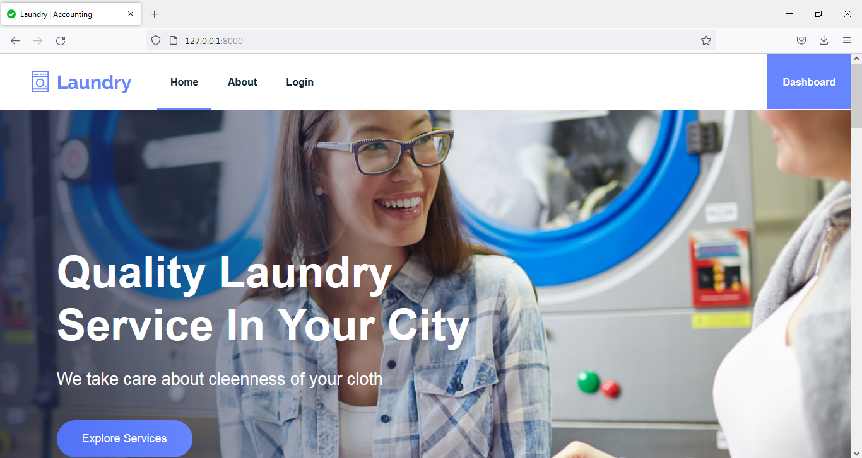

***HOME* PAGE**

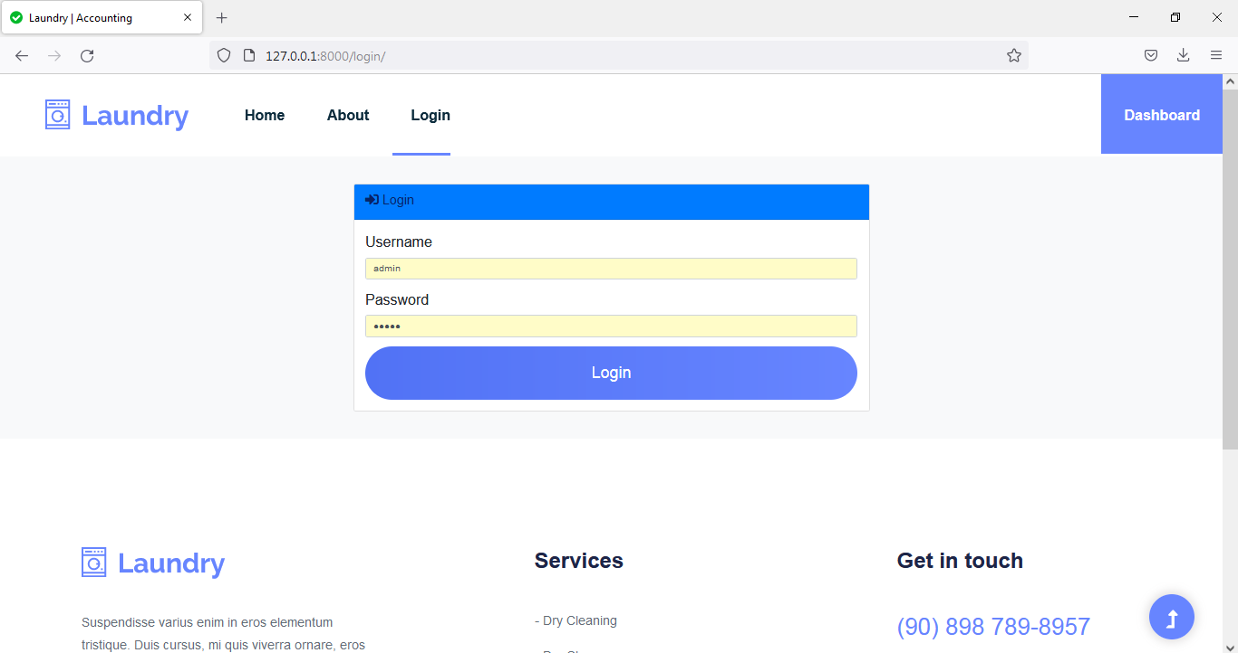

**LOGIN PAGE**

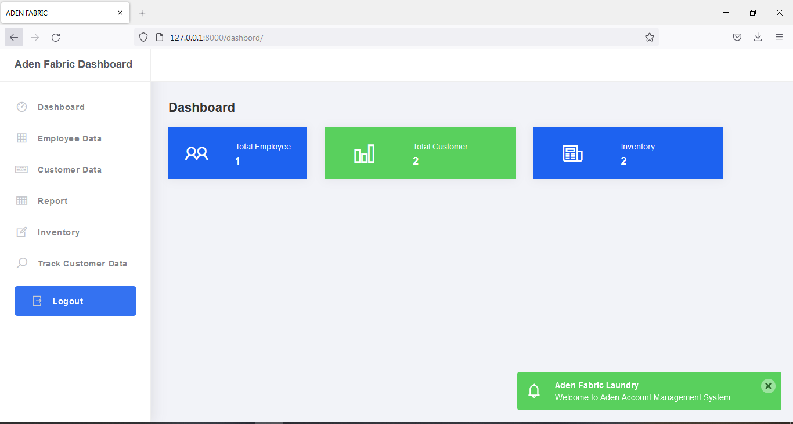

**DASHBOARD**

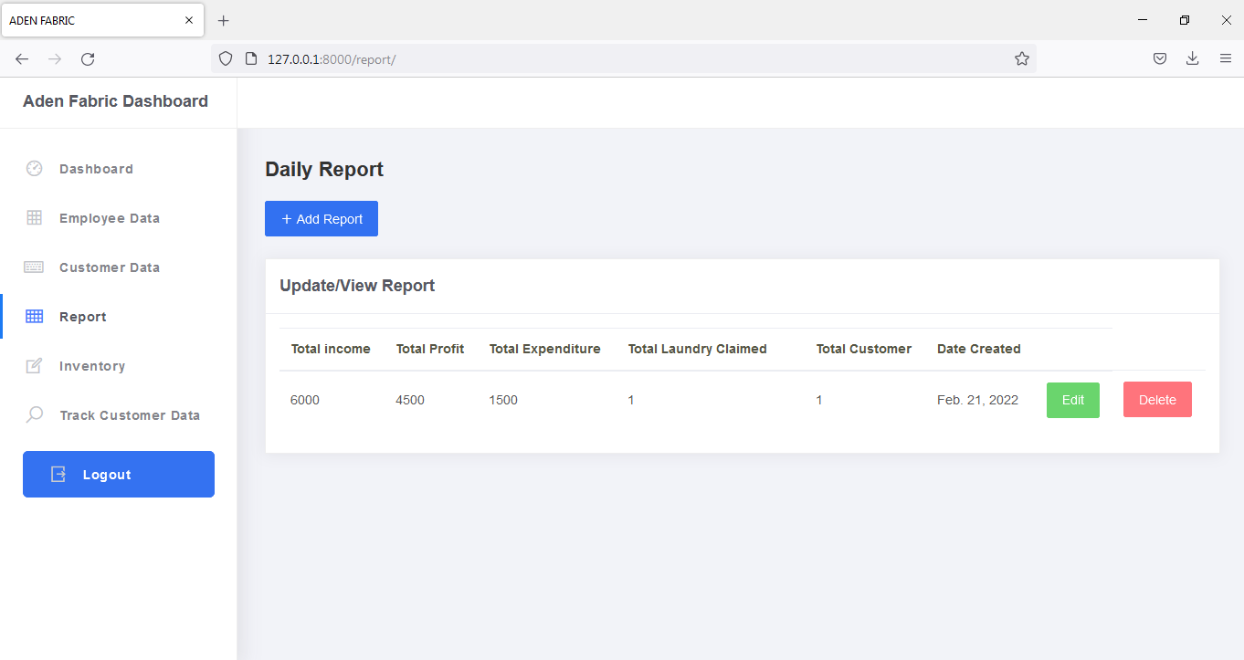

**REPORTS**